

|  |
| --- |
| COMFORT  CLASSIC |

|  |  |  |
| --- | --- | --- |
| Task 3 |  |  |
| Name: Maria Afzal |  |  |

## Introduction:

Classic Comfort is a furniture brand that focuses on providing stylish and comfortable furniture pieces to enhance the ambiance of homes. The brand offers a wide range of products, from classic wooden chairs and sofas to modern designs that cater to various tastes and lifestyles. Their collection includes:

* Sofas: Comfortable and stylish seating options that add a touch of luxury to living rooms.
* Chairs: Various styles, including wooden and accent chairs, designed for both function and aesthetics.
* Dining Tables: Elegant and functional tables that complement dining areas.
* Beds: Comfortable beds designed to provide a restful sleep experience.
* Office Furniture: Practical and stylish pieces that enhance the work environment.

Classic Comfort is known for its dedication to quality and design, aiming to transform houses into homes with furniture that reflects individual tastes. The brand emphasizes both comfort and style, ensuring that every piece not only looks good but also provides a high level of comfort.

## Initial Analysis:

### Present the Original Lighthouse Scores

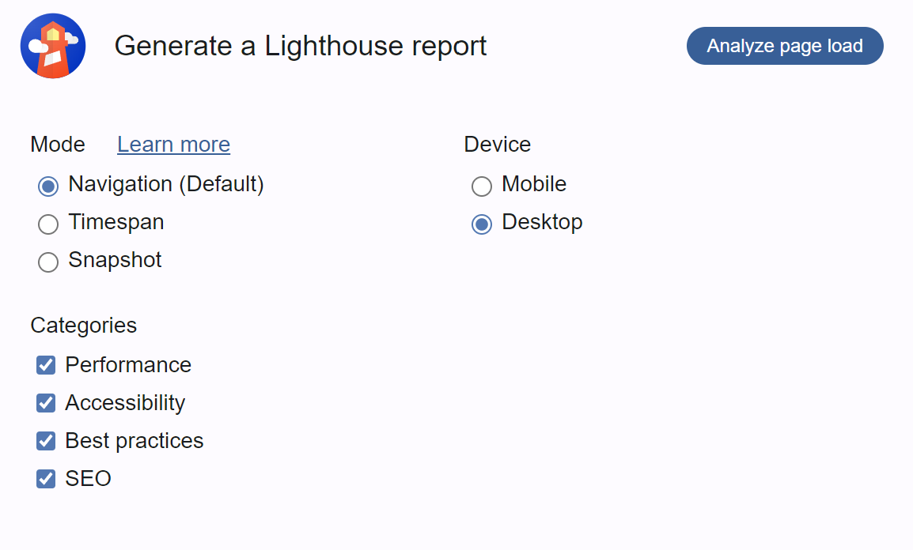



* **Performance**: The performance score reflects how quickly and efficiently the page loads. A high score indicates good performance, while a low score suggests potential issues.
* **Accessibility**: The accessibility score measures how well your site supports users with disabilities. A high score means better accessibility, and a low score indicates areas that need improvement.
* **Best Practices**: This score assesses whether your site follows modern web development best practices, including security and reliability. A higher score suggests adherence to best practices.
* **SEO**: The SEO score evaluates how well your site is optimized for search engines. A high score indicates good SEO practices, while a lower score points to areas for improvement.
* **Progressive Web App (PWA)** (if applicable): This score assesses whether your site meets the criteria for a Progressive Web App, including offline support and reliable performance.

## Optimization Steps:

**Optimize Images**

* **Tool Used**: [ImageOptim](https://imageoptim.com/), [TinyPNG](https://tinypng.com/)
* **Code Snippet**:

html

<img src="optimized-image.jpg" alt="Description" loading="lazy">

**Performance**

* Largest Contentful Paint (LCP)**: A measure of how quickly the main content of your page loads. High LCP times can affect user experience.**
* First Input Delay (FID)**: Measures the time it takes for a page to become interactive. A high FID can result in poor user interaction.**
* Cumulative Layout Shift (CLS)**: Assesses visual stability. High CLS indicates unexpected layout shifts that can disrupt user experience.**

**Accessibility**

* **Color Contrast**: Poor contrast can affect readability for users with visual impairments.
* **Missing Alt Text**: Images without descriptive alt text can be inaccessible to users relying on screen readers.
* **Form Labels**: Missing or improperly associated labels can make forms difficult for screen readers to interpret.

**Best Practices**

* Security Issues**: Look for issues such as insecure connections (HTTP vs. HTTPS), outdated libraries, or vulnerabilities.**
* Deprecated APIs**: Identify and update any deprecated or insecure APIs.**

**SEO**

* **Meta Tags**: Missing or poorly optimized meta tags (title, description) can affect search engine visibility.
* **Mobile-Friendliness**: Issues related to mobile usability can impact search engine rankings and user experience.
* **Structured Data**: Missing or incorrect schema markup can affect how search engines interpret and display your content.

**Final Analysis:**

After implementing the optimization steps, it’s important to perform a comprehensive analysis to evaluate the improvements and confirm that all issues have been addressed. Here’s a detailed approach to the final analysis:



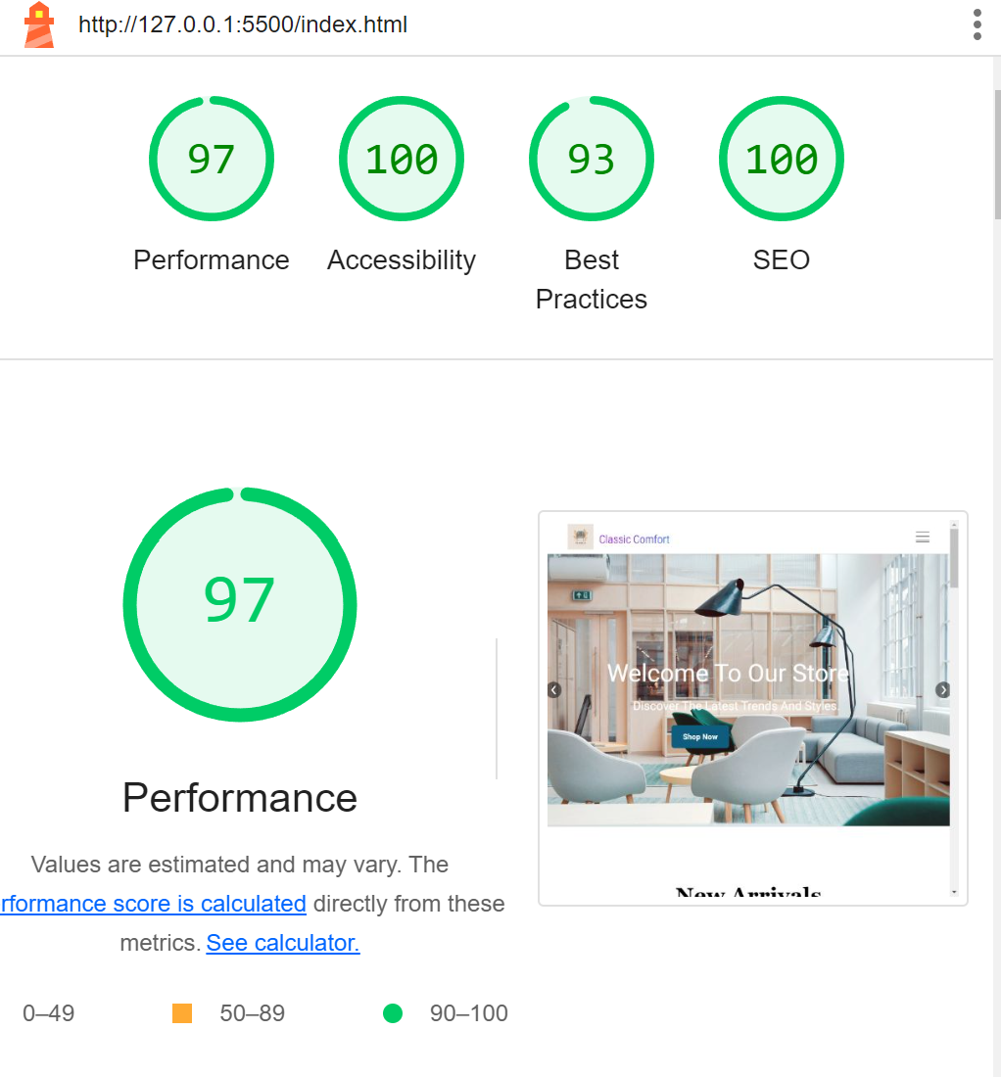

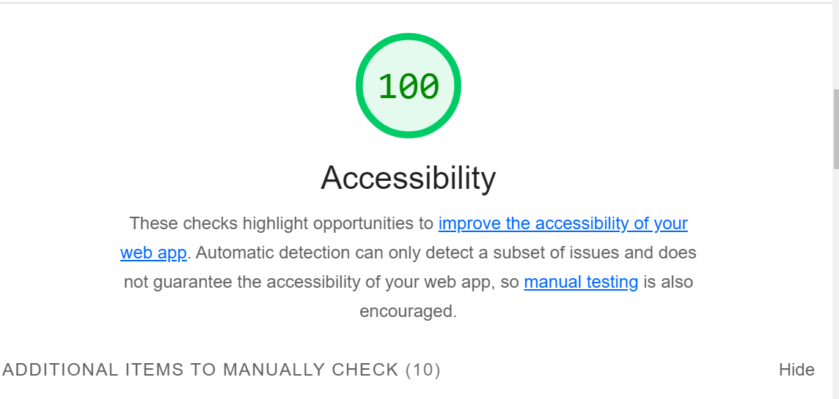

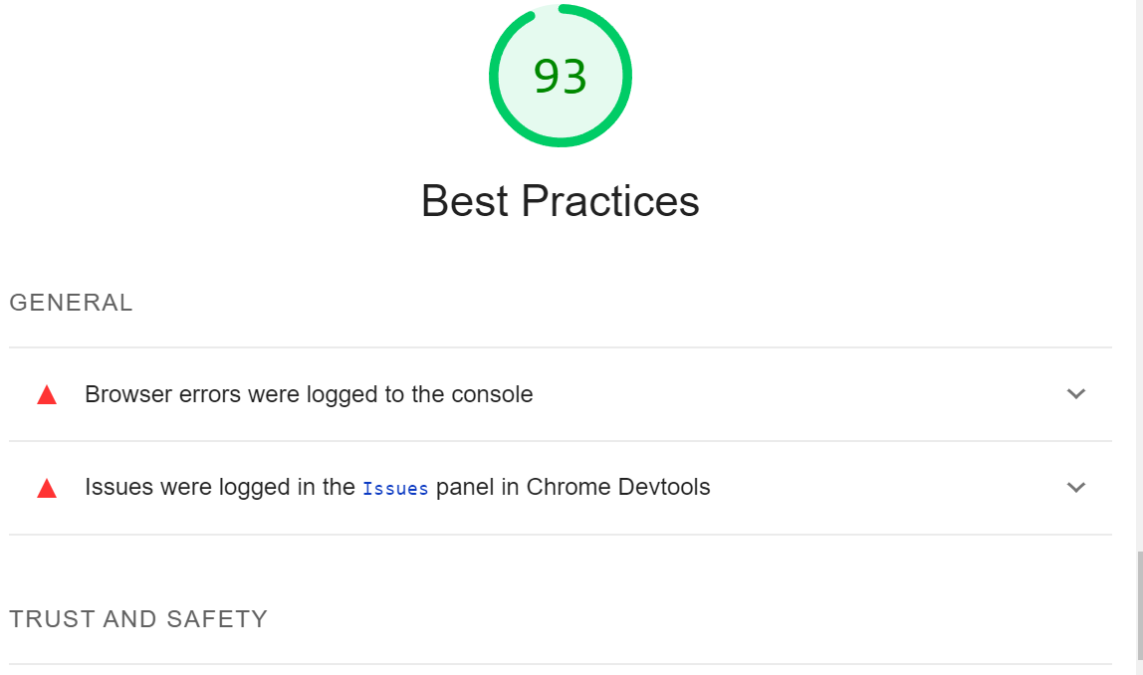

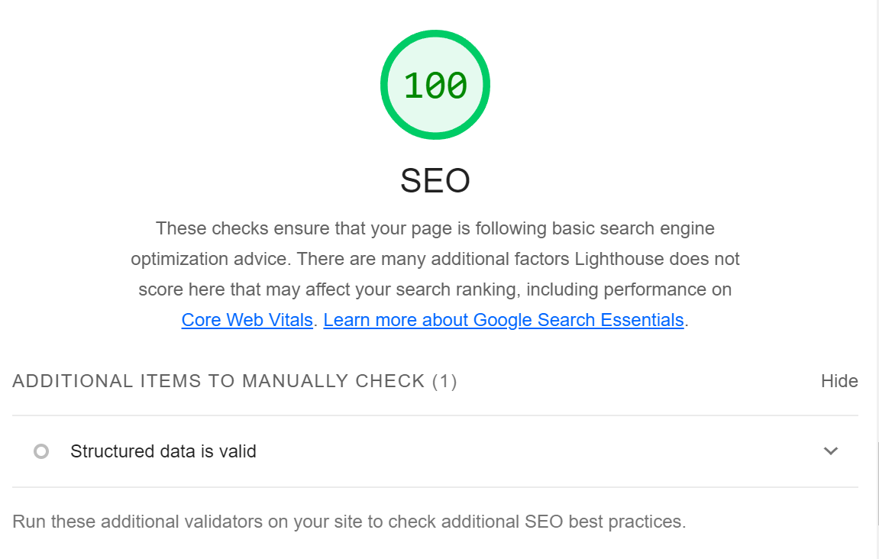

**Conclusion:**

* **Performance: The website’s load times, interactivity, and layout stability have improved. Key metrics show significant enhancements.**
* **Accessibility: The website now adheres to accessibility standards with resolved issues such as alt text, color contrast, and ARIA roles.**
* **Best Practices: The website meets current best practices for security and compatibility. Deprecated APIs have been updated, and security headers are properly configured.**
* **SEO: The website’s SEO performance has improved with optimized meta tags, structured data, and mobile-friendliness enhancements.**